Empires of the IV

# Game Summary

Empires of the IV is a Multiplayer Real-time Strategy Game for PCs, Tablets and Phones, and is displayed in a top-down perspective. In the game, players play as the Unanian Empire and will choose a map and game mode to play with while they connect to each other’s devices. In real-time players manage their military, economy and research to build up their forces and take out the other.

# Five Minute Pitch

It’s the year 2868 on the Galactic Calendar and War. Is. Coming. Play as the Entente, a coalition of three empires and play out war simulations to come up with strategies which can be used in the coming conflict. In the game, Play Singleplayer or multiplayer with friends and gather resources in order to build units to destroy the enemy base.

# Pillars

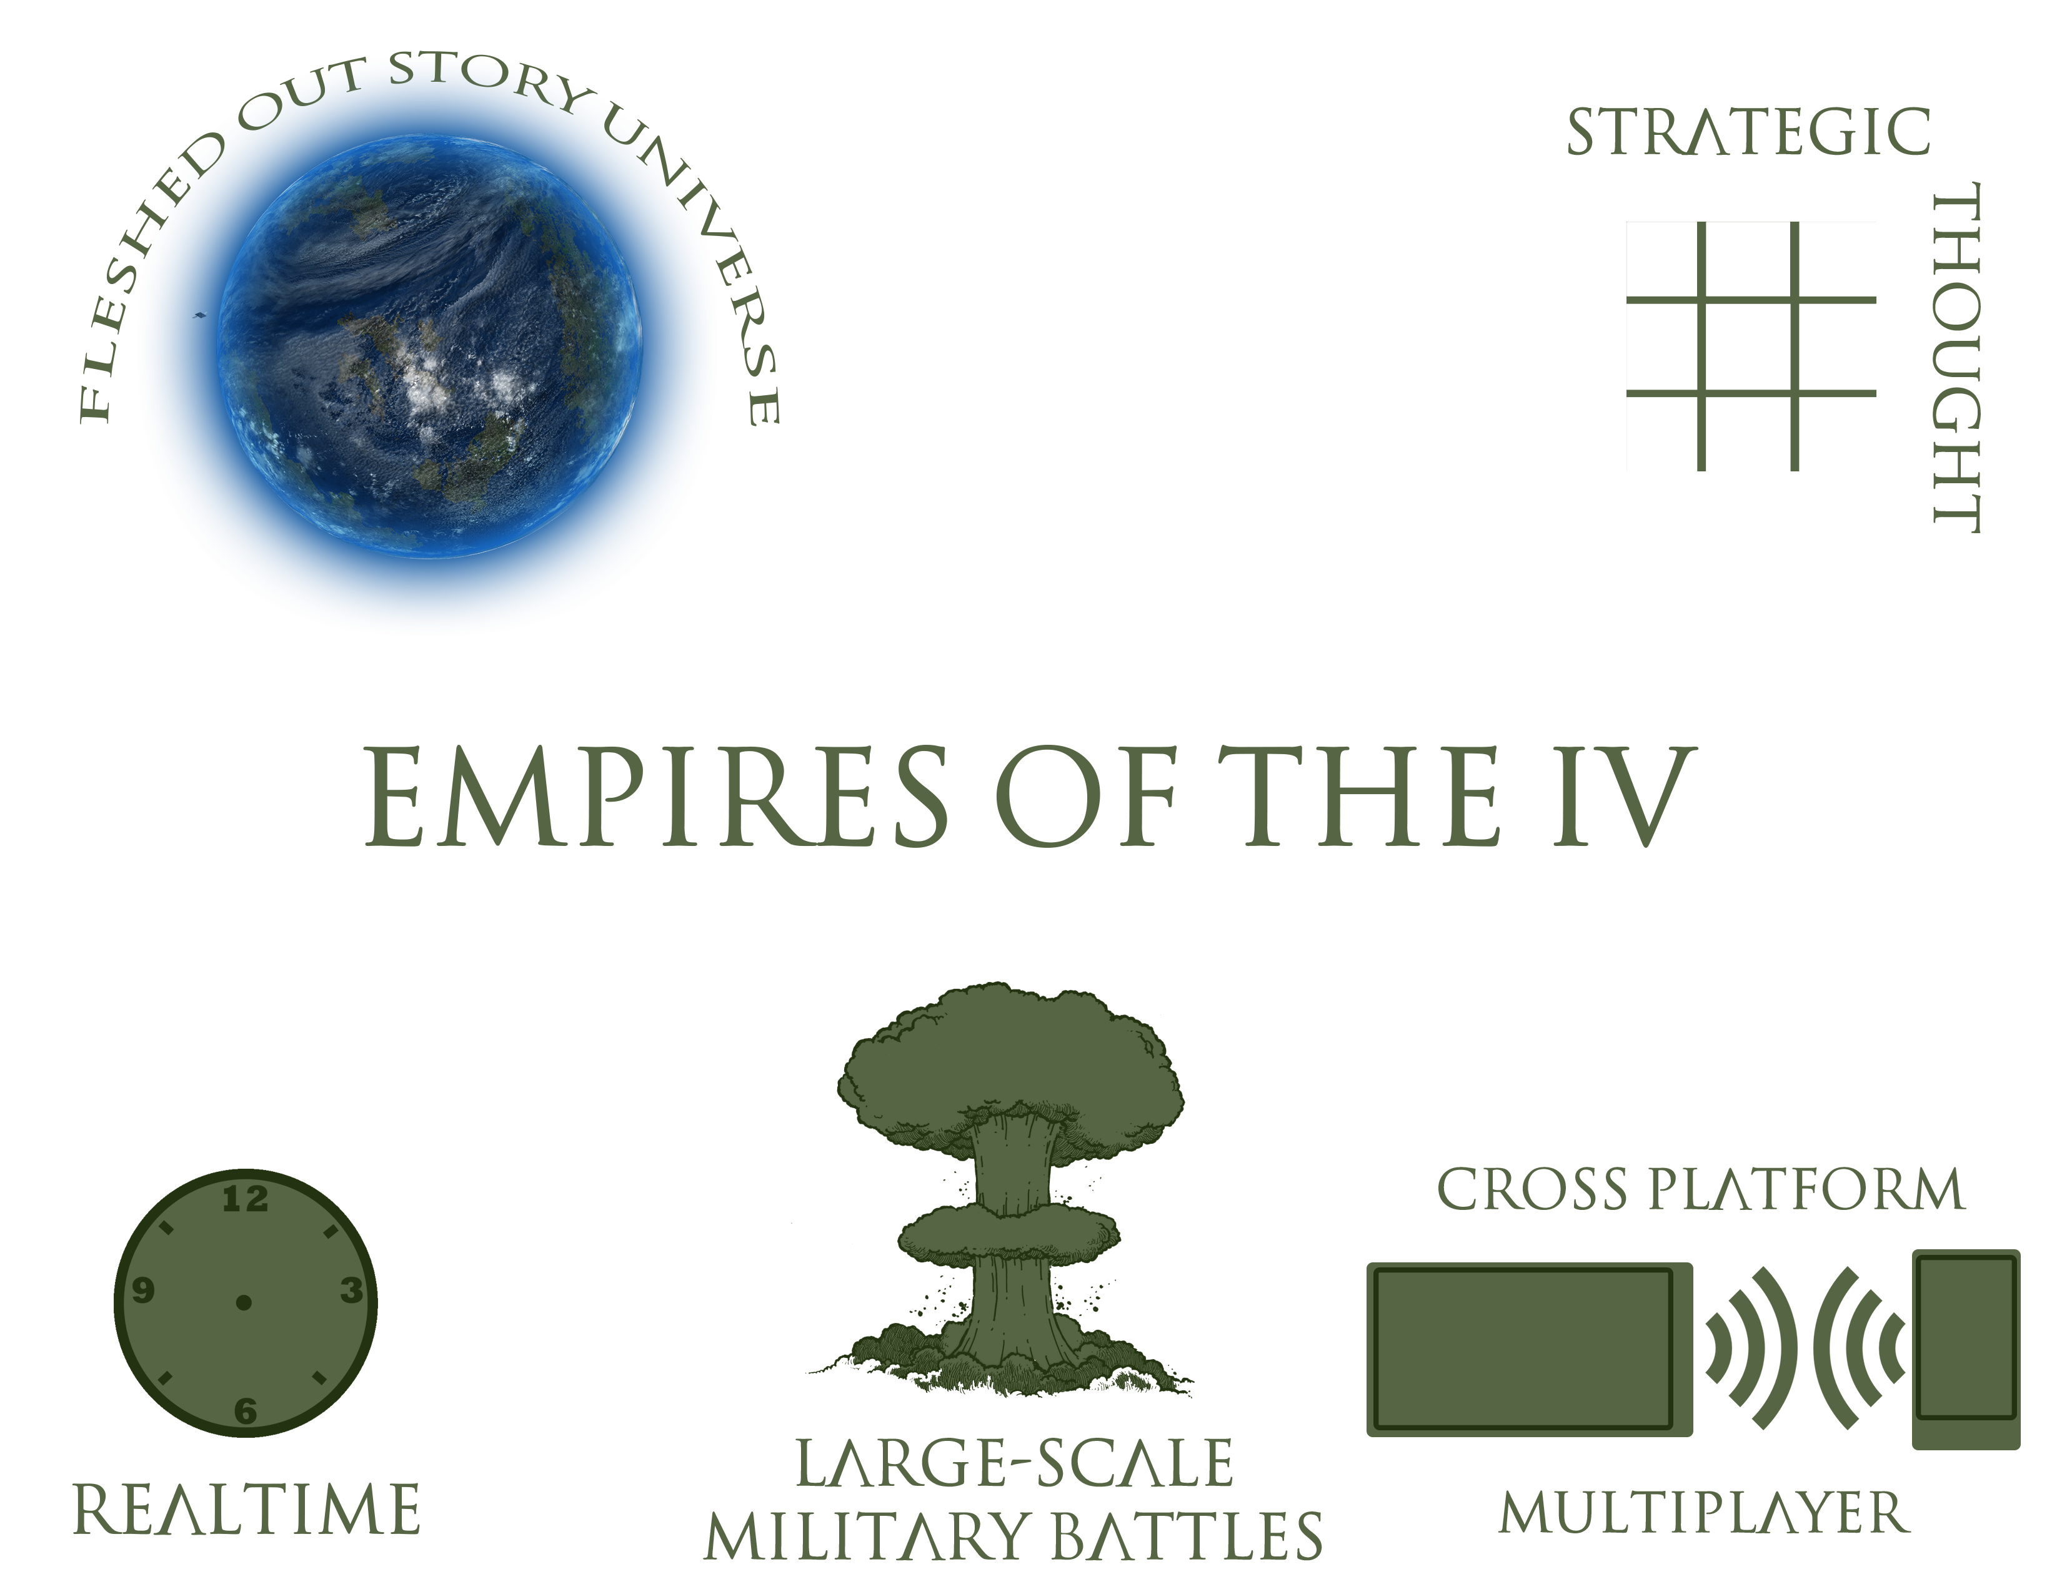

# Game Loop

* Receive data over Network
* Gather Player Input
* Perform Player action
  + Move Unit(s)
  + Attack with Unit(s)
  + Build Units
  + Build Buildings
  + Research
* Check Unit(s) Attack
* Check Building(s) Status’s
* Send data over Network

# Demographics

* Years 13+
  + Rated T for Teen!
* Male
* Windows (Phone) owners (in the future iOS, Android)
* Fans of strategy games
* People who like a little story in their games

# Storyboard - First 5 Minutes

|  |  |  |
| --- | --- | --- |
|  |  |  |
| The Game opens and the player decides whether to play Singleplayer or Multiplayer | Upon selection of Singleplayer, or after the connection of devices in Multiplayer the player lands in the Game Lobby where the Host messes with Game Settings and clicks Play | After a quick load, The match begins and the player is launched into their selected game mode and map. |
|  |  |  |
| The player selects their Factory and begins building units from their factory. | Once they have enough Units, the player selects them and sends them out to battle. | Once the player has enough economy built up, they will likely begin expanding their base by building Supply Points on their Factory’s plots |

|  |  |
| --- | --- |
|  |  |
| At some point the player may have to defend against another player. | If the map supports it, once the player builds up enough economy they may choose to build more Factories on Factory Build Points. |

# Responsible Technical Decisions

|  |  |  |
| --- | --- | --- |
| Frameworks Technology | Pros | Cons |
| MonoGame | Cross Platform  Finer control over the | Would have to make my own engine/tools or find some  Asset Pipeline will change as project goes on due to recent development focus |
| Unity | Cross Platform | Less control over the game operation |
| Unreal | Mostly Cross Platform | Doesn’t support Windows Phone (yet) |

## Technologies

### MonoGame

Because I need the game to be fully cross platform, I have chosen to go with MonoGame. While I could have gone with Unity, I feel like the tradeoff of being forced to build all my tools will better reflect my skills as a programmer

### Json.net

I have gone with JSON.net as my serialization platform due to its ease of use, cross platform compatibility and overall speed which is greater than other alternatives

### Killerrin Studios Toolkit

I am utilizing my own Toolkit I wrote a while ago and continue to maintain which acts as a wrapper around Platform Specific APIs and provides additional capabilities which is gained through helper methods. This Toolkit provides Platform and Form-factor recognition and holds the logic for my Networking code

### Anarian Game Engine

# User Stories

## I want to play with friends

As a user I want to be able to connect to my friends' devices and play with them

## I want a wide variety of ways to play

As a user I want to be able to play different game modes such as FFA, Team Based or something as simple as Defend the Base

## I want to choose from multiple civilizations to play as

As a user I want to be able to choose from multiple civilizations to play as.

## I want a story behind the gameplay

As a user I want a defined story behind why we are fighting each other and how things came to be

## I want to build a large military

As a user I want to be able to build a lot of units to take on my opponent with

## I want to be able to research

As a user I want to be able to make my guys stronger through research.

## I want to be able to chat with my team and enemy

As a user I want to be able to type into a chat to communicate with my team and enemy

## I want a wide variety of settings

As a user I want to be able to customize my game experience through a wide variety of in-game settings